SPACE REQUIREMENTS
Ideally all the spaces listed below are within the hotel that houses the team.

COMMON AREA - BLUE
Starting on Sunday afternoon (for set-up) and finishing on Friday, the Common Area will serve as our chief space to work, present, design, debate and build.
- This space needs to be big enough to hold full-group conversations.
- We’ll need an implied ‘stage – not a stage, per se, but an area for speakers and facilitators that can be seen from the entire room.
- If possible, this space could also house the Team Work Stations. Each Team Work Station will have its own large (preferably 7’ or 8’ round) worktable.
  - Keep in mind that last year we had a separate room for the Team Work Stations. That can work too!
- Most of the walls need to be receptive to large and small post-its. Each team will need their own wall space (at least 10’ wide) to post ideas, insights, feedback and drawings. And, we’ll need communal wall space too.
- Despite needing loads of wall space, we need at least some natural light. We are going to spend quite a bit of time in here so it’s essential that we not feel locked away in a bunker.
- It’s important that the room be a comfortable room temperature. Air conditioning with a thermostat we can control is a must.
- Keep in mind that we’ll have a big group in this room. When people are working in teams, lots of people will be talking at the same time. Good acoustics are critical!!! Be sure to test this and do not take the word of the hotel that the acoustics are good.
- It’s also important that, when a projector is in use, we be able to darken the room enough for people to see the content of the slides. (We will, however, limit use of the projector.)
- While the Immersion doesn’t officially begin until Monday, we need access to this room starting Sunday and staff to help arrange the furniture.
- It’s imperative that we have access to the room at all times during the week and feel confident that our work and valuables are not disturbed in any way and are secure at all times.

COMMON AREA
With Work Stations
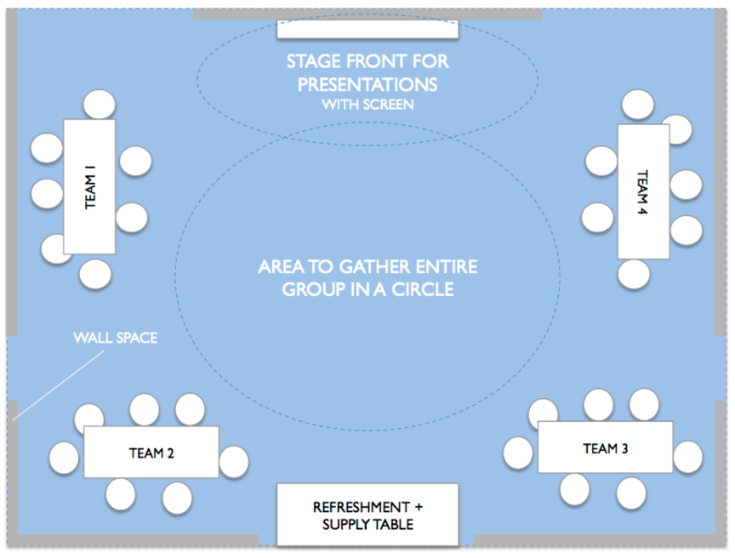
This illustration is just a light suggestion. For example, we might have five teams – not four.
COMMON AREA EQUIPMENT + SUPPLIES
In this space, we will need to have everything previously listed on the supply list and:
- Projector and screen (or white wall onto which we can project)
- Charging station for cell phones, iPads and computers
- Trash and, hopefully, recycling containers
- ‘Field journals’ (one for each Immersion participant)

MAKERS’ CAMP - ORANGE
Either in the Common Area or very nearby, we need to set up Makers’ Camp.
- This room will be where we set up computers, printers, other technology and other means to help bring ideas to life.
- It’d be great to have a few work stations with desks, chairs and good light.
- It’s important that the room be a comfortable room temperature. Air conditioning with a thermostat we can control is a must.
- It’s imperative that work and valuables left in the room are not disturbed in any way and are secure at all times.
- Also imperative is that this room have reliable power sources and the best internet connection possible.
- As with the Common Area, I’s important we have access to this room starting early Sunday.
- This room will need to be accessed and used late at night. Important that participants feel they can make as much noise as they require; therefore, it is best that this room not to be adjacent to guest rooms.

LABS
We need 2 or 3 rooms that we’ll use as labs. This is where we’ll invite end-users (providers, girls, parents, etc. in separate rooms) to provide feedback to our ideas.
- Right now, we only have scheduled to hold labs at the hotel on Wednesday.
- All lab participants will need to arrive early for warm up before they give feedback.
- If we have girls give feedback to our ideas, we need to keep their participation confidential – making sure they have a private entrance where parents and providers do not see them coming and going.
- Keep in mind that it might be perfectly legitimate (and nice) to do a lab outside.

FOOD + DRINK REQUIREMENTS
- All meals should accommodate people who are allergic to nuts, vegetarian or gluten-free. Perhaps the easiest way to accommodate different needs is to serve meals buffet-style.
- When possible people will be encouraged to have breakfast on their own. That said, lets be sure to offer breakfast-appropriate snacks every morning in our Headquarters.
- Because we want to keep people energized throughout the day, it is critical to all breakfast and lunch planning that meals emphasize proteins (yogurts, lentils, cheeses, chicken, fish, nuts, etc.). Lets please avoid carbo-loading our group with pastas, breads, rice, sweets, etc.
- Also at breakfast and lunch, please be sure to offer loads of filtered water and caffeinated drinks. Lets see if we can avoid super sugar-y drinks. Alcohol should not be served.
- At lunch, dessert should be avoided… except for chocolate (for energy!) and fruit. We really want to avoid people crashing after lunch from a sugar-coma.
- Throughout the day, we will need healthy snacks – nuts, granola bars, popcorn, bananas, dried fruit and other fruit, etc. – and an endless supply of filtered water (carbonated and not) and caffeinated drinks.

