OVERVIEW
This document is a draft of a guide suggested for use during the Provider Research to be conducted in partnership with PSI/Tanzania in Morogoro, Bagamoyo and Dar es Salaam the weeks of February 29th and March 7th. Co-leading in this research will be Stacy Barnes, Cathreen Bukuku, Melissa Higbie, Rebecca Hope, Shahada Kinyaga, Irene Lukumay, Edwin Mtei, Madeleine Moore and Pam Scott. The group will be broken up into three teams:

Team A: Stacy Barnes, Cathreen Bukuku, Madeleine Moore (Plus a translator)
Team B: Rebecca Hope, Edwin Mtei, Melissa Higbie (Plus a translator)
Team C: Pam Scott, Shahada Kinayga, Irene Lukumay

Please note that included in this document are more research methods that we will need during any one conversation. The objective was to provide a variety of suggested tools for how critical topics can be explored; however, each team will have the flexibility to do as they see fit in the field. Along the way, we’ll reconvene to discuss insights as well as which methods work hardest and what other methods have been developed that work well.

One specific suggestion, if during the research the provider answers questions from the perspective of providers in general or other providers, allow him/her to do that. Gain some insight and then eventually bring the conversation back to him/her. Given the sensitive nature of the topic – reproductive health services for unmarried adolescents – we want providers to have ease into sharing their own opinions about the same.

Lastly, remember that providers are not only professionals, also members of the community and, in some cases, parents. If time permits, consider exploring how providers relate to the issues we’ll be exploring in their other roles… but only after thoroughly vetting their professional points of view.

INTRODUCTIONS
Before launching into any discussion with a provider, please take care to establish the following:
- We so appreciate the time that he/she has agreed to speak with us.
- We are on a learning journey to better understand the work of medical community in Tanzania.
- He/She is the expert. Not us. We are simply here to ask questions and learn.
- There are no wrong answers. This is about you, your work and the patients you see.
- We encourage him/her to speak openly and honestly. To share with us about his/her work as well as the cultural norms that inform it.
- Answers will be kept in confidence. We will we attach their name to their opinions.
- Similarly, you never need share with us the names of your patients. Lets keep that private.
- Our goal is to learn about his/her work so that we might develop ideas that better support providers like them and the many patients they serve.

FACILITY TOUR
Open with tour of facility. Ask to see the entire clinic, paying special attention to the patient experience – from the waiting room to treatment rooms to checking out and everything in between. Pay close attention how the experience feels, who is involved, what kinds of patients are and aren’t present, who would and wouldn’t feel welcome, what (if any) technology is leveraged, how visits are or aren’t recorded, what educational materials are available, what messages are posted, etc.

Warm-Up Objectives: Get a quick read on a number of important topics and get the provider comfortable sharing. Probe into the answers that are most compelling and/or curious.

FILL IN THE BLANK
Share statements and have provider complete them. (Or, explore by asking simple questions.)
- I started doing this work because __________. I stay in it because __________.
- My job is mostly about __________ but I wish it was more about __________.
- The role I play in my community is __________.
- I know I’m doing a good job when __________.
- The most common need my patients have is __________.

OR

WHAT I DO
Explore how the provider describes what he does, as well as how he believes others describe him in his community. The following can just be discussed or filled in by the provider with words and/or pictures and then discussed. Be sure to address what other providers think. We’re keen to explore the roles of reputation and peer pressure. (Consider having the provider fill out in advance.)

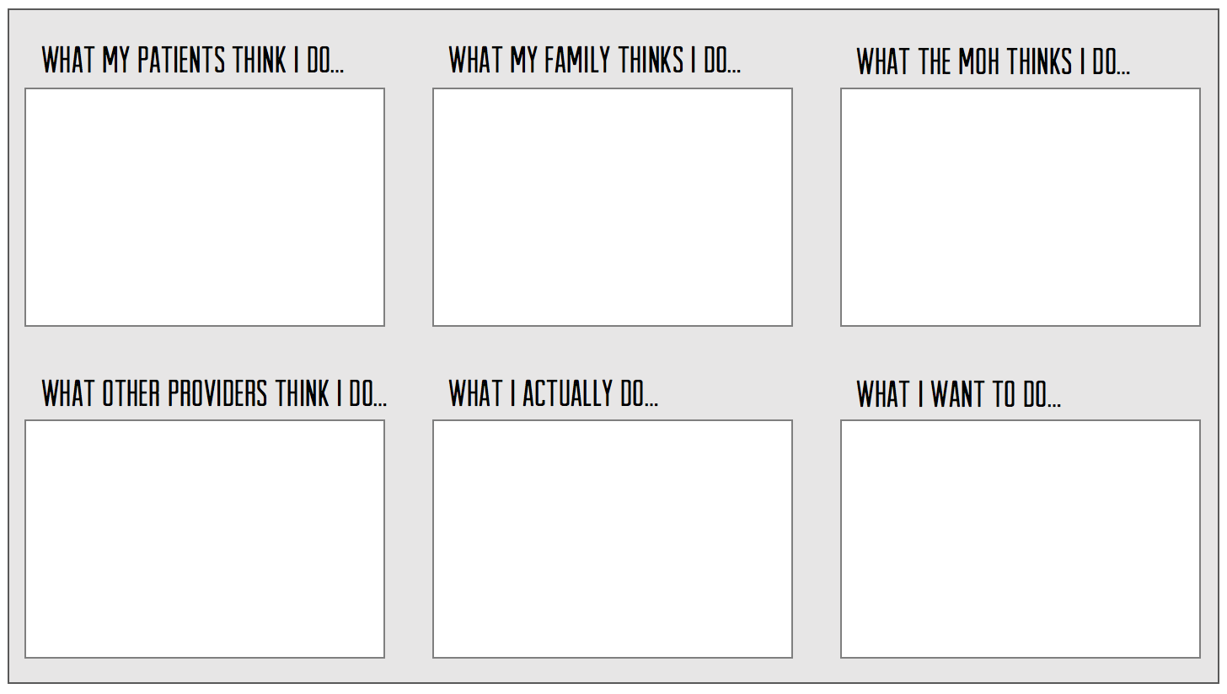

OR

PHOTO SORT
Share 12-20 photos on cards. Ask the provider to pick the one that best represents various things. Use the image as a means to open up conversation about a variety of topics, such as:
- A typical day in your clinic.
- What people most need from you.
- Your role in the community.
- What it feels like to have a really good day at the clinic.
- Your favorite part of your work.
- Your least favorite aspect of your work.
- How fertility is viewed in Tanzania.

Three sets of similar images are being printed.

CONTEXT
Objectives: Open with a conversation that taps into the perceived value, status and associations related to adolescent girls in the community.
- Tell me about the types of clients you tend to serve here.
- You did/didn’t mention adolescent girls. Do they come here? Why or why not?
- For those of us who are not from this country or from this area, we’d love for you to help us understand the adolescent girls in your community.
  - Tell us about the different types of adolescent girls in this community.
  - What does it mean to be a ‘good girl’ in this community? What do those girls have in common?
  - What does it mean not to be a ‘good girl’? What do they have in common?
  - Which do you most commonly see here – good girls or bad girls? Why?
  - In this community, what’s the typical life for a girl who is, say, 13yo?
  - How is or isn’t that different from a typical life of a 13yo boy here?
  - I want to understand if and how boys and girls are regarded differently in this community. Would you say that girls and boys are treated the same? Explain.
    - How are they treated the same?
    - How are they treated differently?
    - Do they have the same opportunities? Why or why not?
    - Do they have the same amount of control of their lives? Why or why not?
    - Do they have the same influence in their families? Why or why not?
    - Are they treated differently in the eyes of the local religion? If so, how?

IMPORTANT: We’re looking for context – feelings, perceptions and associations related to girls – that may shape how adults respond to girls having access to contraception and agency over their bodies.
THIS OR THAT VALUE?
Objective: To understand which values providers identify as most important to them and their work. Use this to understand which values participants perceive as important, and if the significance is static or changes depending on different contexts.

With 10-12 values on individual cards, ask providers to choose one over the other as being most important. See, if by doing this exercise, you can get them to agree on the three or so that are most important. Probe how they inform their work, how they make decisions, how they treat their patients, how they show up in their communities, etc. See which values they hold most dear.

Suggested values to include: Contribution, Integrity, Reputation, Service, Respect, Community, Responsibility, Knowledge, Professionalism, Status, Leadership, Recognition.

TELL A STORY
Objectives: Understand what kinds of women are served by the provider, how the provider feels about his/her female patients and how unmarried adolescents fit into that line-up.

Share cards featuring different types of female patients. Which of these types of women tend to come to your clinic? Narrow down the cards to just those who are served. Add anyone who is missing. For each ask: Do you serve them here? Why or why not?

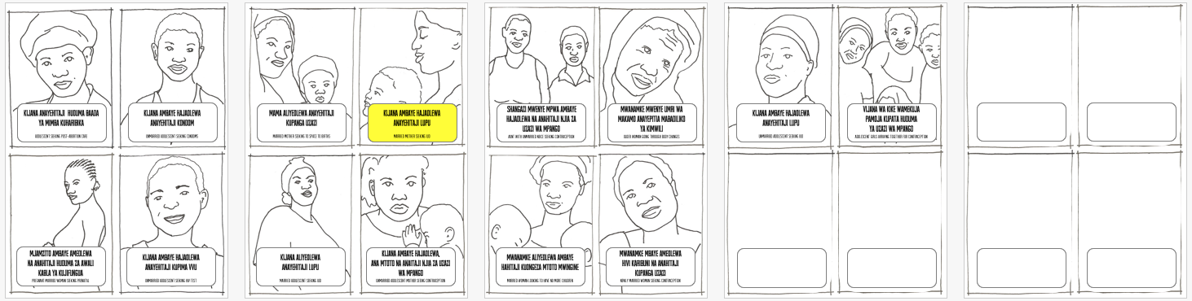

- Ask which 2-3 types of patients he/she feels best about serving. Why?
- Which, if any, which he/she doesn’t feel good about serving. Why?
- How does he/she determine who to serve and who not to serve?
- Be on the lookout for what biases do or don’t come up for adolescents.

‘Randomly’ pick three cards (always include two adolescents) and ask the provider. Ask him/her to tell a story about the typical patient represented on each, filling details such as – who she is, where she came from, what services she wants, how comfortable he/she is serving her, where else he/she might recommend she go, etc. See what attributes and biases are noted for adolescents. Gauge the provider’s comfort and confidence levels in treating each.

Consider having the provider match different forms of contraception* (we’ll have printed illustrated cards for all of the various forms) to the women for whom the methods are right.

Put in front of the provider just the five cards featuring adolescents. Discuss their differences, their similarities, as well as, teasing apart feeling about serving married and unmarried. Try to unearth which has the most stigma or which are socially acceptable to serve.

IMPORTANT: Gauge if there are conditions or circumstances that make adolescents more acceptable to serve, like the adolescent is a) already sexually active, b) has already conceived, c) is married.

*ALTERNATIVE: If you didn’t ask the provider to match the contraception to the appropriate female patients, you can have him/her cluster the contraception according to how it makes sense to him/her. Then, of course, discuss.

TOPIC SPECTRUM
Objectives: Continue focusing on just adolescents by exploring whether the provider believes SRH is a valid and appropriate topic to address with adolescents and why. Discuss which topics are appropriate and which should be off limits.

First, ask the provider whether he/she believes it’s appropriate to discuss sexual and reproductive health with unmarried adolescent girls. If not, why not? If so, why and which topics do they feel are appropriate to discuss with girls? Then, share with the provider stickies with a different SRH topic noted on each. Ask him/her to add any topics he/she feels are missing.

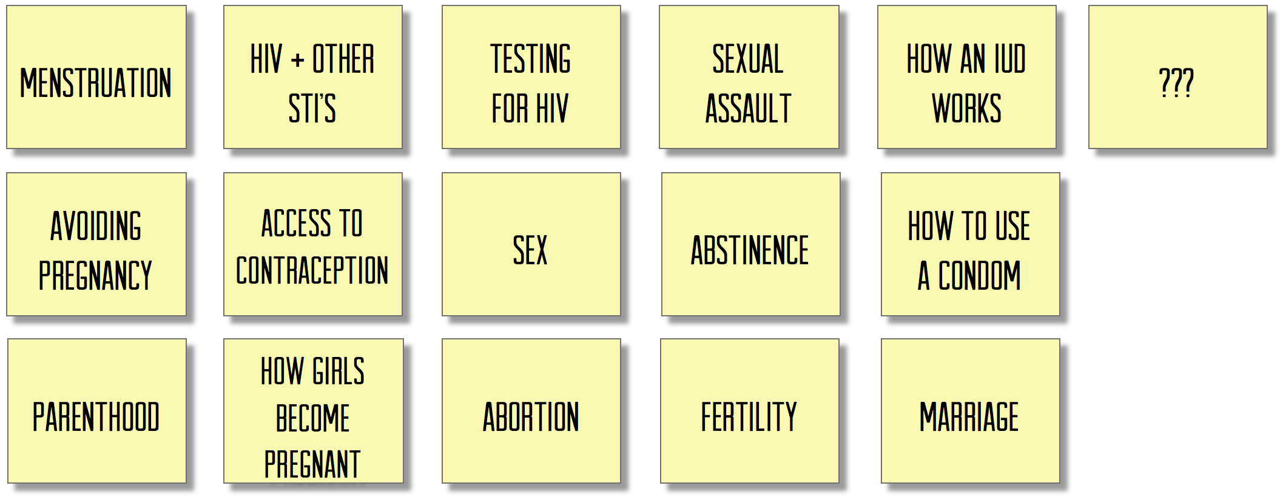

Once the list is complete, have his/her place each topic on a spectrum from least appropriate to most appropriate topics to be addressed (by no one in particular) with unmarried adolescent girls. At this point do not address who has the responsibility to address with adolescent girls. Just get a clean read on which should and shouldn’t be addressed.

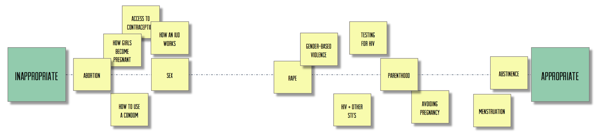

Once he/she has indicated what is and isn’t appropriate to discuss with unmarried adolescent girls:
- Discuss the ranking with the goal of understanding the logic behind it.
- IMPORTANT: Determine the perceived risk in talking to unmarried adolescent girls about the least appropriate topics, as well as what makes other topics more appropriate.
- IMPORTANT: Figure out what circumstance might move a topic closer to ‘appropriate’ and acceptable. Determine why.
- Without judgement explain what topics are considered appropriate in other countries. Discuss. Gauge reaction.
- IMPORTANT: Discuss how, if at all, his/her opinion changes under different circumstances, like the adolescent is a) already sexually active, b) has already conceived, c) is married.

RESPONSIBILITY BULLS-EYE
Objectives: Explore the perceived responsibility providers deem stakeholders (including themselves) have in educating girls about SRH, as well as risk associated with taking responsibility.

Assuming the providers believes there is some level SRH education that is necessary for unmarried adolescent girls, share with them stickies with all the possible stakeholders who might hold some responsibility in that task. Add anyone they believe is missing. Have them map the level of responsibility each stakeholder holds in educating girls about their sexual and reproductive health.

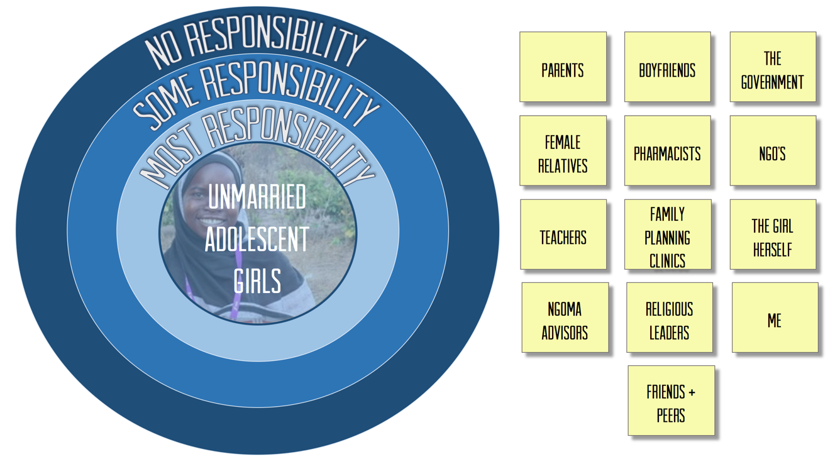

- Unpack where the providers assign and justify responsibility assigned to various stakeholders.
- Pay close attention to whom they appoint as most responsible and why.
- IMPORTANT: Probe deeply into his/her sense of responsibility or lack thereof.
- IMPORTANT: Try to understand the perceived relationships between the stakeholders. Who, in particular, has influence over the provider?
- IMPORTANT: Ask the provider to explain where they placed themselves on the bulls-eye.
- Ask the provider what types of training/resources/information they would need to make them feel more comfortable taking responsibility for those conversations with adolescent girls.
- Without judgement explain the responsibly might be perceived elsewhere in the world. Discuss. Gauge reaction.

IMPORTANT: Wherever the provider places his/her stickie, move it further into the center. Discuss:
- What it would take to be comfortable taking on that amount of responsibility?
- From whom or what they’d need permission?
- What would they be willing to discuss with and offering to adolescents – educational information, counseling, access to LFA contraception, etc.?
- What would be at risk (perceived or actual) if they did assume more responsibility?
- What could the reward be for taking more responsibility?

PROVIDER ARCHETYPES
Determine what the perceived differences in the types of providers in the community and their POV on ASRH of each archetype.
- Whether they currently do or not, who in the local medical community could serve the RH needs of adolescent girls? Who else? Who else? (Come up with a thorough list. Add to as necessary.)
- Put each provider named on a different card or stickie.
- Tell me a little bit about each provider, especially those we don’t know.
- Cluster the providers into groups that make sense to you, giving particular focus on serving adolescent girls.
- For each cluster, explore:
  - Explain the group.
  - What are the pros and cons of being in the group?
  - What does this group believe in?
  - What or who influences the thinking of individuals in this group?
  - What’s most important to this group?
  - How does this group feel about providing contraception to unmarried adolescent girls?
  - How does this group feel about providing contraception to married adolescent girls?
  - What do you believe is their perceived risk of serving unmarried adolescent girls?
- Ask them to identify which group they’d be in and why.
- Ask what about their group is often misunderstood.
- IMPORTANT: Experiment with what it would take to move them to another group that might be more willing to serve adolescent girls.

WHAT IF?
Objectives: Gauge what, if anything, opens up new ways of thinking about and possibly acting on providing reproductive health serves to unmarried adolescent girls.

Share with the provider 5-8 concept statements (that evolve as the research progresses) to determine whether any have impact on the provider’s POV as it pertains to providing RSH services to unmarried adolescent girls. Possible concept statements may include:

- What if Tanzanian law stated that all adolescents – married or not – have a legal right to contraceptive services?
- What if there was a national campaign featuring parents urging providers like yourself to give unmarried adolescent young women access to contraception? (Consider featuring the same concept but change out the person urging – the new President, a respected provider, etc.)
- What if there was a poster in your clinic that stated, under law, you must provide all adolescents the reproductive services they ask for? And, you and your staff had to sign it before it was put on the wall?
- What if you made more money providing contraceptive services to unmarried adolescent young women than any other member of the community?
- What if there was a taxi service for girls that could bring unmarried adolescent girls interested in contraceptive services to your clinic? Would you serve them?
- What if there was a radio program designed to teach adolescent girls – married or not – about reproductive and sexual health?
- What if there was a box you could give or sell to adolescent girls – married or not – that had in it all the products and information they need for their sexual and reproductive health?
- What if every menstruating adolescent between the ages of 14 and 19 were required to use a long-acting form of contraception?
- What if the medical community of Tanzania was internationally recognized the for trying to reduce adolescent pregnancy rates?
- What if President Magufuli declared it the responsibility of the medical community to make sure fewer adolescents become pregnant unintentionally?
- What if your religious leader asked you to do more to address unintended pregnancy among adolescents in the community?
- What if medical professionals who denied adolescent girls access to contraception where fined or even put in jail?

Have the provider cluster the concept statements into three buckets:
- Might make me more open to providing contraception to all adolescents
- Might make me less open to providing contraception to all adolescents
- Makes no difference

Discuss, paying particular attention to anything that opens to the door… even just a little bit.

NEW PRODUCT/SERVICE
Objective: Identify what might make provider more comfortable giving adolescents access to contraceptive services.

Suggest PSI is planning to design services for providers to implement for adolescent reproductive health. Our job is to solicit from him/her regarding what he/she finds most interesting… and why.v Share ideas (that evolve as the research progresses) on cards. These might include:
- Technically accurate SRH brochures written for teens by teens.
- Training specifically for providers to better understand how to treat sexually active adolescents.
- Posters stating that it’s the law that they serve all adults (including adolescents) who inquire about contraceptive services.
- A financial incentive to treat teens who ask for contraceptive services.
- An award for providing the most contraception adolescents in a year.

CLOSE
In closing, please be sure to thank the provider for his/her time. Let them know how valuable their input is and ensure that we will make sure their thoughtful opinions will be put to good use. If he/she inquires about next steps, let him/her know that we are conducting researching Morogoro, Bagamoyo and Dar. Following all interviews, we will synthesize the learning and determine whether there’s anything we can do to help providers do what they do even better.

If helpful, ask the provider if we might be able to engage their further. Possible future engagements might include:

- Participating in a group conversation with other members of the community.
- Sitting on a panel with other providers at the immersion.
- Giving feedback on prototypes at the immersion.

Before inviting any provider to further participate, please confirm with your teammates that they agree this is a good idea.

